Virus & Anti-Virus

Submitted in partial fulfillment of the requirements

of the Mini-Project 1 for Second Year of

Bachelors of Engineering

by

Chaitanya Vijay Parab - 32  
Katheem Kizhar Ahmed - 13

Shaikh Mohd Shoeb - 53

Amman Akhtar - 39

Guide: Prof. Nayna Dahatonde



Department of Computer Engineering

Rizvi College of Engineering



University of Mumbai

2021-2022

**CERTIFICATE**

This is to certify that the mini-project entitled **Cyber Security Vulnerability Analysis** is a bonafide work of Chaitanya Vijay Parab, Katheem Kizhar Ahmed, Shaikh Mohd Shoeb, Amman Akhtar, submitted to the University of Mumbai in partial fulfillment of the requirement for the Mini-Project 1 for Second Year of the Bachelor of Engineeringin **“Computer Engineering”**.

(Name and sign) (Name and sign)

**Nayna Dahatonde External Examiner**

_______________ ______________

Prof. Shiburaj Pappu Dr. Varsha Shah

**Head of Department** **Principal**

Declaration

I declare that this written submission represents my ideas in my own words and where others' ideas or words have been included, I have adequately cited and referenced the original sources. I also declare that I have adhered to all principles of academic honesty and integrity and have not misrepresented or fabricated or falsified any idea/data/fact/source in my submission. I understand that any violation of the above will be cause for disciplinary action by the Institute and can also evoke penal action from the sources which have thus not been properly cited or from whom proper permission has not been taken when needed.

-----------------------------------------

(Signature)

-----------------------------------------

Chaitanya Parab - 32

Katheem Kizhar Ahmed - 13

Shaikh Mohd Shoeb – 53

Amman Akhtar - 39

Date:

**ABSTRACT**

A computer virus, much like a flu virus, is designed to spread from host to host and has the ability to replicate itself. Similarly, in the same way that flu viruses cannot reproduce without a host cell, computer viruses cannot reproduce and spread without programming such as a file or document. Antivirus is a kind of software used to prevent, scan, detect and delete viruses from a computer. Once installed, most antivirus software runs automatically in the background to provide real-time protection against virus attacks. Comprehensive virus protection programs help protect your files and hardware from malware such as worms, Trojan horses and spyware, and may also offer additional protection such as customizable firewalls and website blocking.

**Keywords : –** Virus, Antivirus, Computer, Loopholes

Index

|  |  |  |  |
| --- | --- | --- | --- |
| Sr. No | Title | | Page No |
| 1. | Introduction | | 6 |
| 2. | Review and Literature | | 7 |
|  | 2.1. | Paper 1 | 7 |
|  | 2.2. | Paper 2 | 8 |
| 3. | Report on the Present Investigation | | 9 |
| 4. | Results and Discussions | | 11 |
| 5. | Conclusion | | 13 |
| 6. | References | | 15 |
|  | Acknowledgement | | 16 |
|  | Publication | | 17 |

**Chapter 1**

**Introduction**

A computer virus, much like a flu virus, is designed to spread from host to host and has the ability to replicate itself. Similarly, in the same way that flu viruses cannot reproduce without a host cell, computer viruses cannot reproduce and spread without programming such as a file or document. In more technical terms, a computer virus is a type of malicious code or program written to alter the way a computer operates and is designed to spread from one computer to another. A virus operates by inserting or attaching itself to a legitimate program or document that supports macros in order to execute its code. In the process, a virus has the potential to cause unexpected or damaging effects, such as harming the system software by corrupting or destroying data. Antivirus is a kind of software used to prevent, scan, detect and delete viruses from a computer. Once installed, most antivirus software runs automatically in the background to provide real-time protection against virus attacks. Comprehensive virus protection programs help protect your files and hardware from malware such as worms, Trojan horses and spyware, and may also offer additional protection such as customizable firewalls and website blocking.

**Chapter 2**

**Review of Literature**

**Paper I**

**Computer Virus and Antivirus Software –A Brief Review**

Now a day’s computers are a very essential part of our life. In today’s world of extreme competition on the business front, information exchange and efficient communication is the need of the day. The internet is the highway that connects you to millions of computers together globally, forming networks in which any computer can communicate with any other computer as long as they are both connected to the internet. This fantastic world of computers and their worldwide network has been replete with incidences of malicious attacks of a virus created by people who get the thrills of spotting loopholes and making an entry into other computer systems. 'Virus' is a generic term for software that is harmful to your system. They spread via disks, a network, or via services such as email. Irrespective of how the virus travels, its purpose is to use or damage the resources of your computer. The history of the worst computer virus attacks dates back to 1998 and since then the world of computers has witnessed several computer attacks which were shocking in their times. Now (from 2010 onwards) computer attacks are not shocking anymore, the world of computers has learned to take into its stride computer attacks and has also learned to deal with malware. Viruses are classified as Compiled viruses, Boot Sector viruses, Interpreted viruses, Multi-partite Viruses, and Radio Frequency Identification [RFID] viruses. There are different computer viruses and their variants that are created and find their way into other computers through networks and media. But there is some mechanism to find particular viruses and their categories.

**Paper II**

**Review of Viruses and Antivirus Patterns**

With the Internet as a major essential communication between billions of people and also a tool for commerce, social interaction, there are increasingly new threats in viruses as new unrecognized signatures are evolving for the antiviruses to detect during the scan. Antivirus software uses a virus signature to find a virus in a computer file system, allowing to detect, quarantine and remove the virus. In the anti-virus software, the virus signature is referred to as a definition file or DAT file. Anti-virus software performs frequent virus signature, or definition, updates. These updates are necessary for the software to detect and remove new viruses. New viruses are being created and released almost daily, which forces anti-virus software to need frequent updates. The ability to detect heuristically or generically is significant, given that most scanners now include more than 250k signatures and the number of new viruses being discovered continues to increase dramatically year after year. Further, Landesman indicates that to maintain the highest level of protection, configure your antivirus software to check for updates as often as it will allow. Keeping the signatures up to date doesn't guarantee a new virus will never slip through, but it does make it far less likely.

**Chapter 3**

**Report on the Present Investigation**

**The main purpose of this project was to make an anti-virus that does not interfere with your daily tasks without slowing down your computer and is easy for developers.**

**This Project explores how viruses access our computers and what large Tec - companies do to fight them.**

**Python was used to create Anti- Virus due to it being easy and easy to understand.**

**Other languages were also used to create Viruses for example C, C++, Python and VB etc.**

Flowchart -

**Chapter 4**

**Results and Discussions**

In case your computer is attacked by a virus, it can affect your computer in the following ways:

* Slow down the computer
* Damage or delete files
* Reformat hard disk
* Frequent computer crashes
* Data loss
* Inability to perform any task on the computer or the internet

Antivirus software is like a ray of bright light in a world full of dark viruses. The number of advantages that they offer are countless. Some of the most prominent advantages are:

* Protection from viruses and their transmission
* Block spam and ads
* Defence against hackers and data thieves
* Ensures protection from removable devices
* Protects your data and files
* Supercharge your PC
* Firewall protection from spyware and phishing attacks
* Limit the access of websites to enhance web protection
* Keeping an eye on kids
* Protects your password
* Cost-effective

**Output**

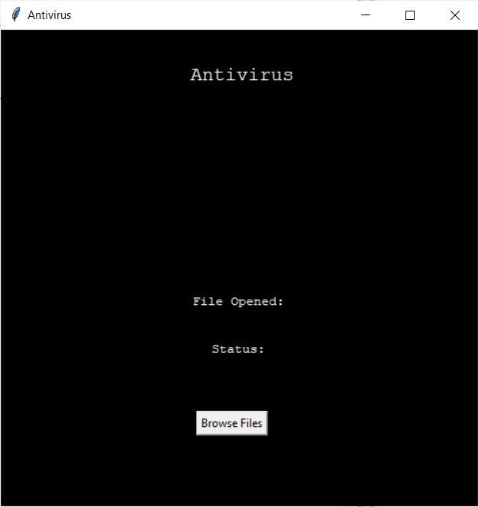

**Chapter 5**

**Conclusions**

An Antivirus is developed using Python and Virus is developed using C++, python and other languages. Through this antivirus, we tend to develop the antivirus direction in a way that it takes less memory and fast response and believe that following developments of antivirus will make it progress in this direction while also not affecting its efficiency. Also, our virus is used to make users aware of the loopholes and hope that they resolve this loophole without creating new ones.

**POs & PSO**

|  |  |
| --- | --- |
| **Project** | **Outcome** |
| **Cyber Security** | **Malware identification using Python.** |
| **Education** | **Know how the virus functions and what type of Vulnerability it uses.** |

**Chapter 6**

**References**

[1] Martin C. Brown, 2018, Python: The Complete Reference.

[2] Muchelule Yusuf Wanjala & Neyole Misiko Jacob, 2017, Review of Viruses and Antivirus

Patterns, Global Journal of Computer Science and Technology.

[3] Bhaskar V. Patil, Rahul J. Jadhav, 2015, Computer Virus and Antivirus Software –A Brief Review, International Journal of Advances in Management and Economics.

[4] Alun L. Lloyd, R. M. (18th May 2001). How Viruses Spread Among Computers and People. Science, New Series, pp. 1316-1317.

[5] Spafford, E. H. (1994). Computer Viruses as Artificial Life. Journal of Artificial Life, MIT Press, pp.1-23.

[6] Paul Mobbs, Computer Viruses, Association for Progressive Communications, March 2002.

[7] Robin Sharp, An Introduction to Malware, Spring 2011.

[8] Paul, Sophos Plc, Computer Virus Demystified. PDF, ISBN 0-9538336-0-7.

**Acknowledgements**

I am profoundly grateful to Prof. Nayna Dahatonde for his expert guidance and continuous encouragement throughout to see that this project rights its target.

I would like to express deepest appreciation towards Dr. Varsha Shah, Principal RCOE, Mumbai and Prof. Shiburaj Pappu HOD Computer Engineering Department whose invaluable guidance supported me in this project.

At last, I must express my sincere heartfelt gratitude to all the staff members of Computer Engineering Department who helped us directly or indirectly during this course of work.

Chaitanya Parab

Shaikh Mohd Shoeb

Katheem Kizhar Ahmed

Ammaan Akhtar Sayed

**Publications**

[Add you published research paper on this topic in any Conference / Journal.]

